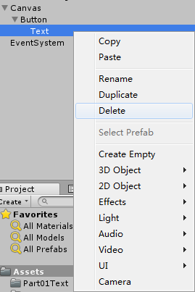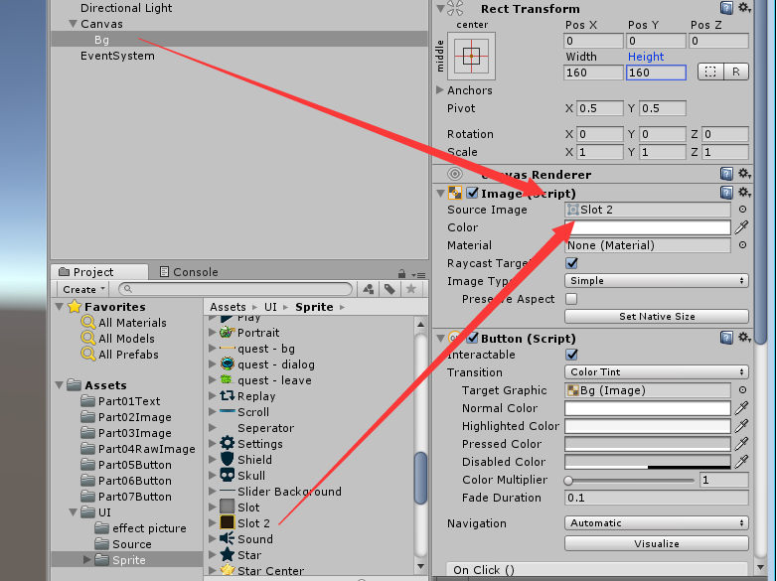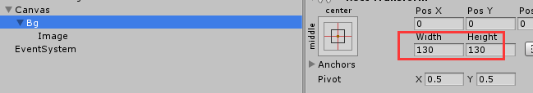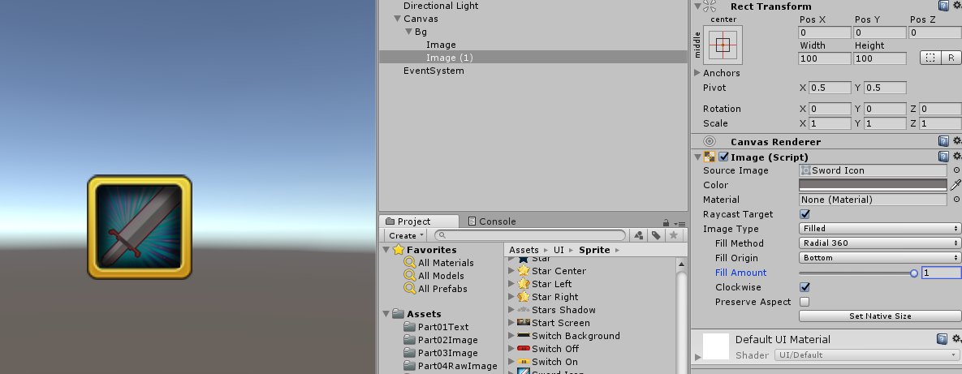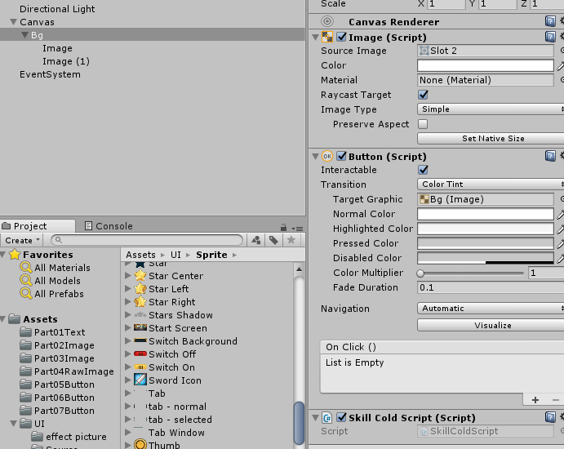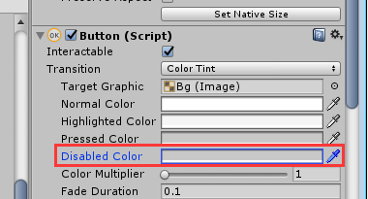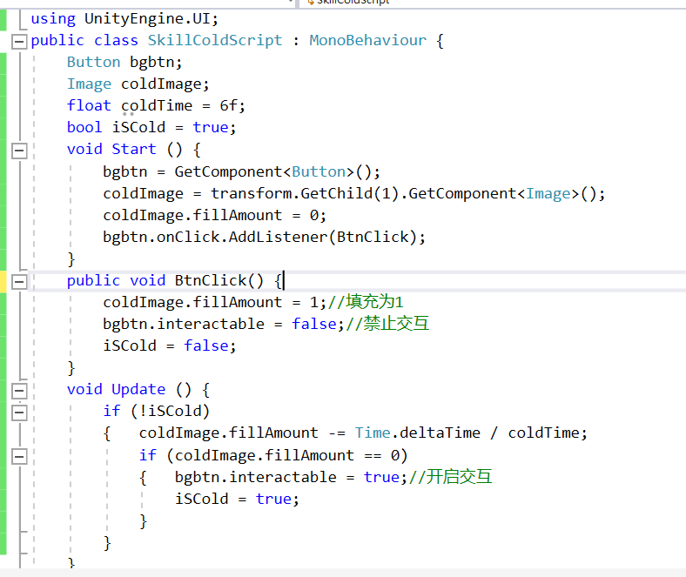

using UnityEngine.UI;

public class Skillcold : MonoBehaviour

{

Button btn;

Image image;

float coldTime = 6f;

bool isCold = true;

void Start()

{

btn = GetComponent<Button>();

image = transform.GetChild(1).GetComponent<Image>();

image.fillAmount = 0;

btn.onClick.AddListener(BtnClick);

}

public void BtnClick()

{

//填充为1

image.fillAmount = 1;

btn.interactable = false;//禁止交互

isCold = false;

}

void Update()

{

if (!isCold)

{

image.fillAmount -= Time.deltaTime / coldTime;

if (image.fillAmount == 0)

{

btn.interactable = true;//开启交互

isCold = true;

}

}

}

}